Results — Morphometric responses to diet
Mixed-effects models revealed strong effects of growth period across all morphometric traits (Period: p≤0.020 for height and p<0.001 for width, length, and girth), confirming substantial increases from initial to final measurements (Table X; significance map). Sex effects were also significant for all traits (p≤0.019), indicating marked sexual dimorphism.
Diet effects were trait-dependent. Girth showed a pronounced overall diet effect (Diet: p<0.001) and a significant Diet×Period interaction (p=0.020), indicating that dietary treatments altered girth accretion over the experimental period. In contrast, main Diet effects were not detected for height, width, or length when averaged across sex and period (p≥0.132).
Importantly, diet responses were sex-specific for some traits. Width exhibited significant Diet×Sex (p=0.001) and Diet×Sex×Period interactions (p=0.003), while height showed a significant Diet×Sex×Period interaction (p=0.029), demonstrating that dietary effects on growth trajectories differed between males and females. Length was comparatively diet-insensitive, showing no evidence of diet-related interactions, with only a marginal Sex×Period trend (p=0.087). Overall, these findings indicate that diet primarily modulated body conformation and tissue deposition (particularly girth), and that diet effects on growth trajectories were sex-dependent for width and height.

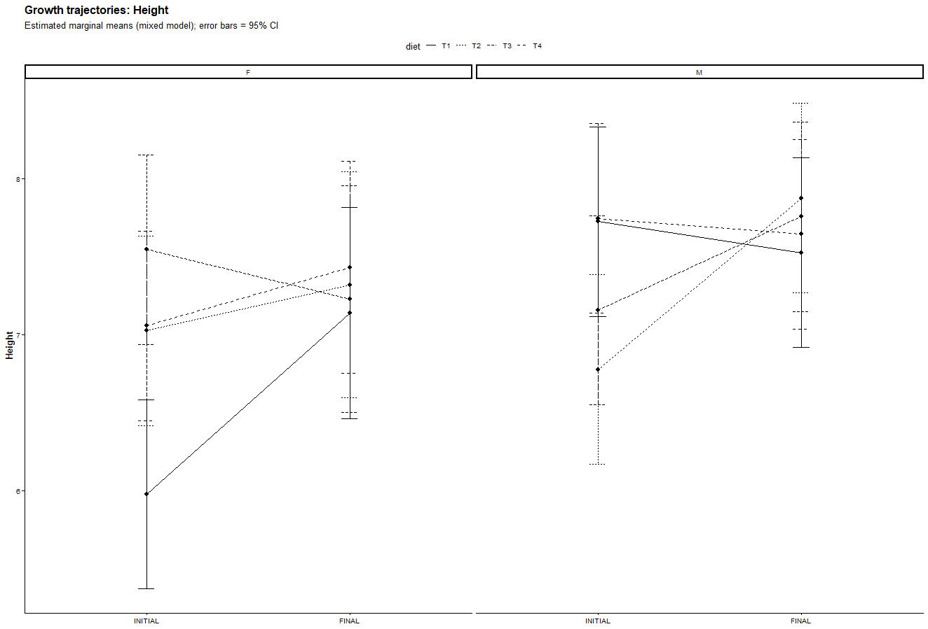
Height increased significantly from the initial to the final measurement period across all treatments (Period effect, p = 0.020; Figure X). Males were consistently taller than females (Sex effect, p = 0.006), indicating clear sexual dimorphism. Although no overall main effect of diet on height was detected, a significant Diet × Sex × Period interaction (p = 0.029) revealed sex-specific dietary modulation of height growth trajectories. In females, some diets promoted greater height gain than others, whereas in males, dietary responses differed in both magnitude and direction. These results indicate that dietary effects on skeletal height development are context-dependent, emerging only when sex and growth stage are considered jointly.
Diet did not uniformly affect skeletal height, but altered height growth trajectories in a sex-specific manner.

PCA RESULTS
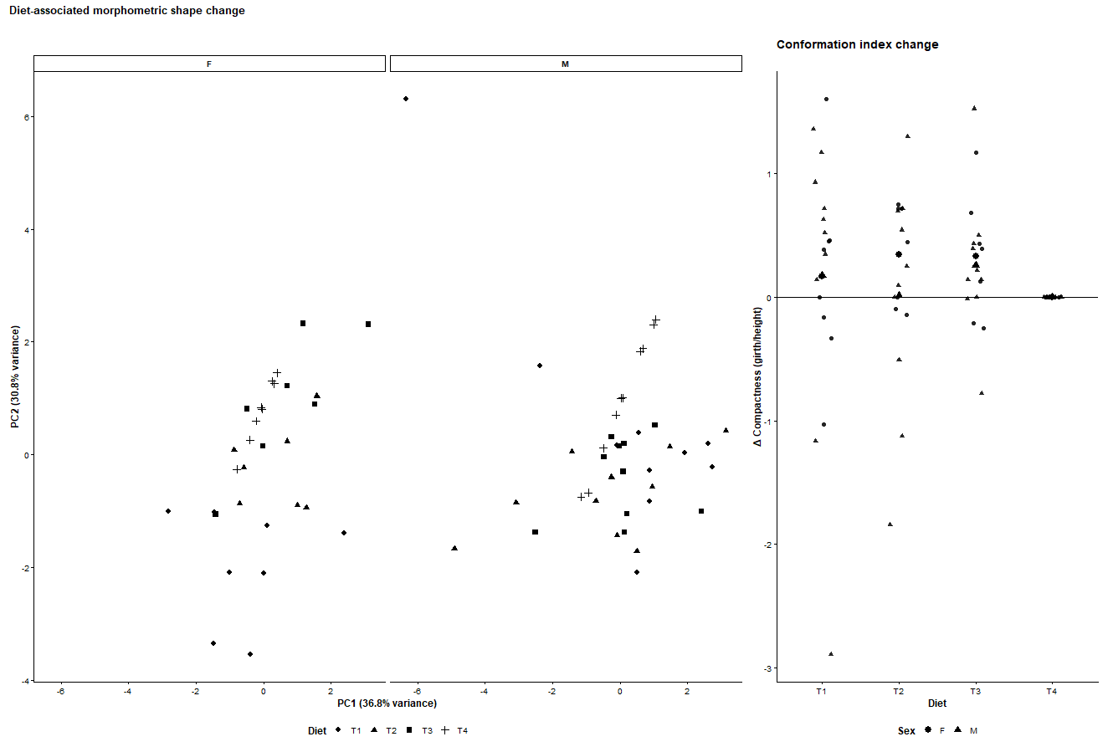
One-sentence interpretation (Nature Food–style)
“Diet treatments induced distinct, sex-modulated morphometric shape changes, with multivariate analysis and conformation indices indicating differential allocation of growth between skeletal frame and tissue deposition.”
In the results section:
Principal component analysis of morphometric changes (final − initial) revealed clear diet-associated shifts in body shape, explaining 68% of total variance across the first two components (Fig. X). Separation along PC1 reflected differential allocation of growth between skeletal dimensions and tissue accretion, while PC2 captured secondary shape variation. These patterns were broadly consistent across sexes but showed sex-specific dispersion, indicating modified nutrient partitioning. Consistent with the PCA, changes in compactness (girth/height) differed among diets, with some treatments promoting increased tissue deposition relative to frame growth (Fig. X).

Statistical analysis
All analyses were conducted in R (version X.X.X). Morphometric traits (height, width, length and girth) were analysed using linear mixed-effects models to account for repeated measurements, with diet, sex and measurement period (initial vs final) and their interactions included as fixed effects, and individual animal included as a random intercept. Model assumptions were assessed visually using residual and Q–Q plots. Estimated marginal means and 95% confidence intervals were obtained from fitted models to visualise growth trajectories and treatment effects. Changes in morphology were quantified as differences between final and initial measurements (Δ values), and additional conformation indices were calculated to describe relative body shape. Multivariate patterns of morphometric change were explored using principal component analysis (PCA) on standardized Δ traits and indices, with scores examined by diet and sex to assess clustering and shape differentiation. Statistical significance was assessed at α = 0.05.

